Venue Location Analysis using Foursquare and other Python’s libraries

Braulio J. Cabral

Coursera

06/14/2019

Abstract

[The abstract should be one paragraph of between 150 and 250 words. It is not indented. Section titles, such as the word Abstract above, are not considered headings so they don’t use bold heading format. Instead, use the Section Title style. This style automatically starts your section on a new page, so you don’t have to add page breaks. Note that all of the styles for this template are available on the Home tab of the ribbon, in the Styles gallery.]

Keywords: [Click here to add keywords.]

Venue Location Analysis using Foursquare and other Python’s libraries

# Introduction

A critical factor when opening a franchise is to determine if the location is suited for such venue. Other factors, such as distance from other franchises of the same corporation or competitor franchises are also important, as well as the need for people traffic through the location (Franchise Help, 2019). The business problem discussed in this paper relates to the need of a franchisee to validate a location for a new venue given by his corporate sponsor. Mr. John Doe received a proposed location in the town of Falling Waters, WV to open a fast food franchise. Event when the corporation’s suggestion looks appealing, he wanted to know more about the rationale, or come to his own conclusion to decide if he should proceed.

I proposed the use of Foursquare to collect a dataset of all businesses in the area and use data science techniques to analyze the dataset and see what we could learn from it. In the following sections of this paper, I will describe the dataset, the methodology and main components used in the exploratory analysis of the data and the resulting discovery.

## The Dataset

The proposed location is a small shopping center located at [39.56375, -77.887494]. The first approach in generating a data set was to map out all businesses in a 10-miles radius of this location. Businesses included all categories, competitors, such as fast food restaurants, and any other businesses that could serve similar menu items, such as small coffee shops or sandwich. places). To generate the dataset, at first, my approach was to use the above coordinates and run a single search. Unfortunately, that approach returned a number of businesses smaller than the actual number of business in the area. I then decided to list all coordinated of small towns in the area and loop through them to generate single outputs, then aggregate them into a super data frame. This approach resulted in a data frame with 368 business.

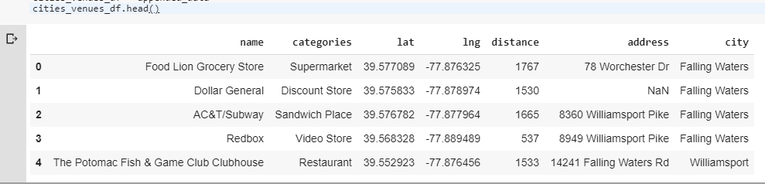

Fig. 1 (Data Frame of surrounding businesses)

The dataframe above describe each venue as a row with the corresponding features of name of the venue, categories, latitude, longitude, the distance of the venue in relation to the proposed location, its address and the corresponding city or town. A very important feature here is the “distance” from the proposed location, for both, competing businesses, and non-competing. For competing businesses such as those of the same category as the new franchise, it will give us an idea of how strong the competition may or may not be in the proposed location, and for non-competing businesses, we can learn about the potential customers traffic in the area.

## Methodology

The first step in the exploratory data analysis of the above dataset was to produce a visual depiction of where the businesses are in relation to the proposed location. Using folium, a library the builds on the strengths of Python’s data wrangling capabilities and leaflet.js, I was able to produce a map and superimposed all businesses by their coordinates. To have a better view of where each corresponding town is, I overplayed each town as a colored circle enclosing the businesses.

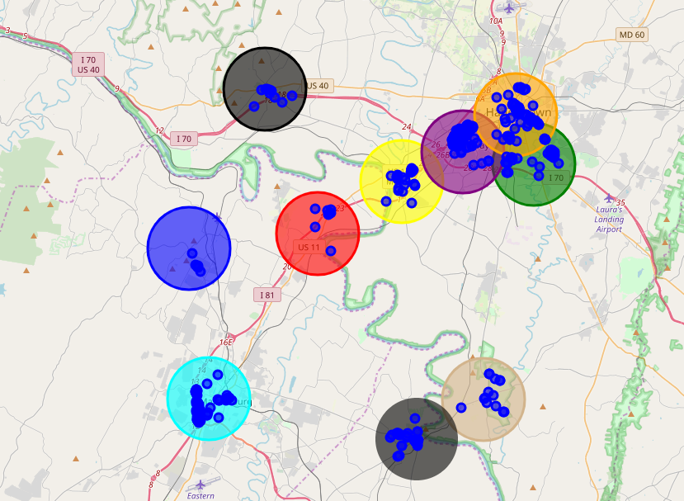

Fig. 2-Businesses locations and towns.

The map above shows how the businesses are naturally clustered within the different town’s boundaries. Later, we can see if using an algorithm such as KMeans produces a similar clustering. There were 112 unique business categories identified, the array below shows each category.

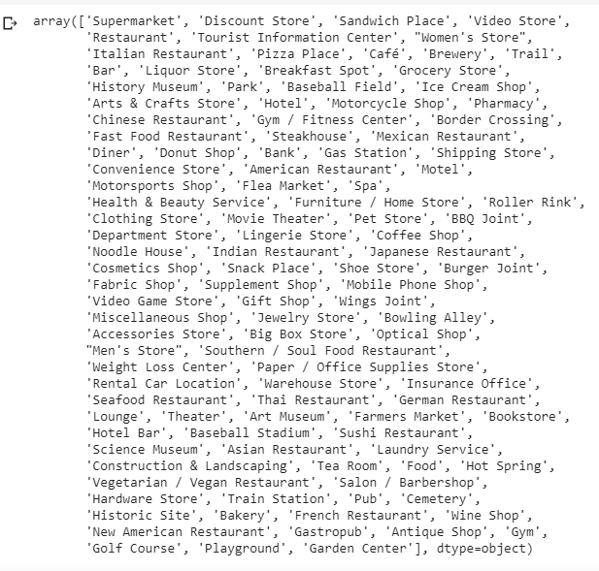

Fig. 3 -Array of businesses categories

[To add a table of contents (TOC), apply the appropriate heading style to just the heading text at the start of a paragraph and it will show up in your TOC. To do this, select the text for your heading. Then, on the Home tab, in the Styles gallery, click the style you need.]

### [Heading 3].

[Include a period at the end of a run-in heading. Note that you can include consecutive paragraphs with their own headings, where appropriate.]

#### [Heading 4].

[When using headings, don’t skip levels. If you need a heading 3, 4, or 5 with no text following it before the next heading, just add a period at the end of the heading and then start a new paragraph for the subheading and its text.] (Last Name, Year)

##### [Heading 5].

[Like all sections of your paper, references start on their own page. The references page that follows is created using the Citations & Bibliography feature, available on the References tab. This feature includes a style option that formats your references for APA 6th Edition. You can also use this feature to add in-text citations that are linked to your source, such as those shown at the end of this paragraph and the preceding paragraph. To customize a citation, right-click it and then click Edit Citation.] (Last Name, Year)

References

Franchise Help (2019). Where Is The Best Location To Open Your Franchise? Extracted from URL: https://www.franchisehelp.com/franchisee-resource-center/where-is-the-best-location-to-open-your-franchise-/

Last Name, F. M. (Year). Article Title. *Journal Title*, Pages From - To.

Last Name, F. M. (Year). *Book Title.* City Name: Publisher Name.

Footnotes

1[Add footnotes, if any, on their own page following references. For APA formatting requirements, it’s easy to just type your own footnote references and notes. To format a footnote reference, select the number and then, on the Home tab, in the Styles gallery, click Footnote Reference. The body of a footnote, such as this example, uses the Normal text style. (Note: If you delete this sample footnote, don’t forget to delete its in-text reference as well. That’s at the end of the sample Heading 2 paragraph on the first page of body content in this template.)]

Tables

Table 1

[Table Title]

|  |  |  |  |  |
| --- | --- | --- | --- | --- |
| Column Head | Column Head | Column Head | Column Head | Column Head |
| Row Head | 123 | 123 | 123 | 123 |
| Row Head | 456 | 456 | 456 | 456 |
| Row Head | 789 | 789 | 789 | 789 |
| Row Head | 123 | 123 | 123 | 123 |
| Row Head | 456 | 456 | 456 | 456 |
| Row Head | 789 | 789 | 789 | 789 |

Note: [Place all tables for your paper in a tables section, following references (and, if applicable, footnotes). Start a new page for each table, include a table number and table title for each, as shown on this page. All explanatory text appears in a table note that follows the table, such as this one. Use the Table/Figure style, available on the Home tab, in the Styles gallery, to get the spacing between table and note. Tables in APA format can use single or 1.5 line spacing. Include a heading for every row and column, even if the content seems obvious. A default table style has been setup for this template that fits APA guidelines. To insert a table, on the Insert tab, click Table.]

Figures title:

Figure 1. [Include all figures in their own section, following references (and footnotes and tables, if applicable). Include a numbered caption for each figure. Use the Table/Figure style for easy spacing between figure and caption.]

For more information about all elements of APA formatting, please consult the APA Style Manual, 6th Edition.